Test Case: tc003_SPX_Dev5_Crear_Requisicion_Spot_Tipo_Cobro_CC_Urgent
Step 1 - Enter username and password and click to button Enter : Credentials Entered
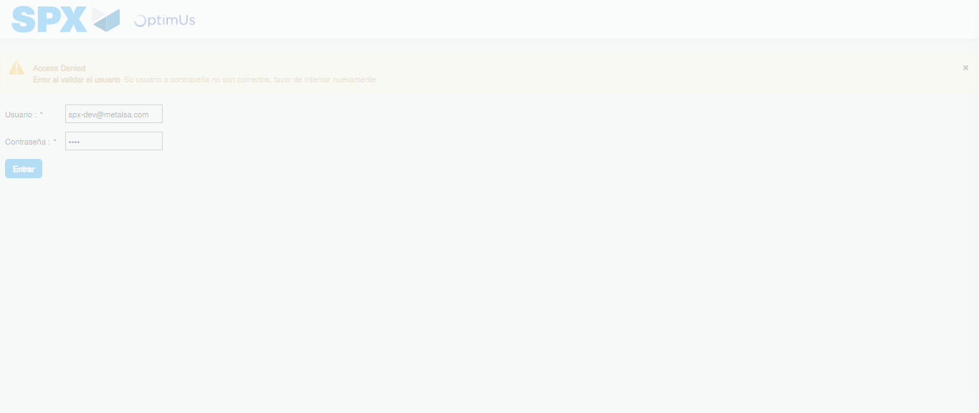Image file-name: QC_Testing-tc003_SPX_Dev5_Crear_Requisicion_Spot_Tipo_Cobro_CC_Urgent-1783356588315

Step 2 - Select to UEN and Access to Spot Buy Requisitions : UEN Correctly selected and Correct access
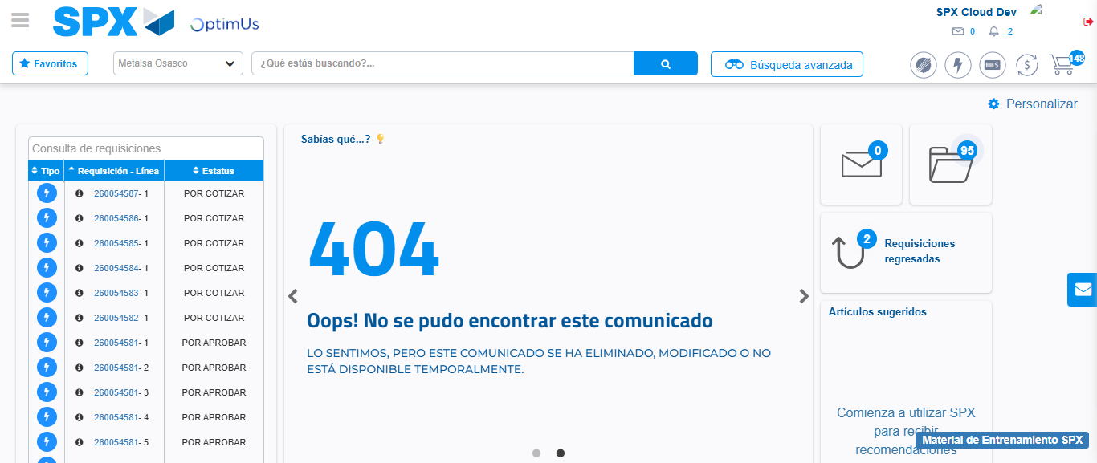Image file-name: QC_Testing-tc003_SPX_Dev5_Crear_Requisicion_Spot_Tipo_Cobro_CC_Urgent-1783356613902

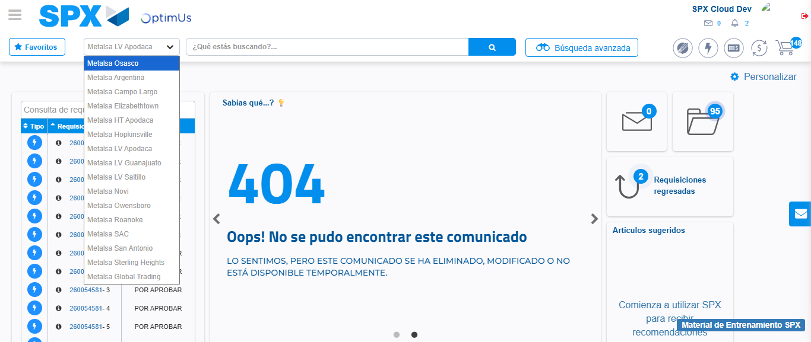Image file-name: QC_Testing-tc003_SPX_Dev5_Crear_Requisicion_Spot_Tipo_Cobro_CC_Urgent-1783356616753

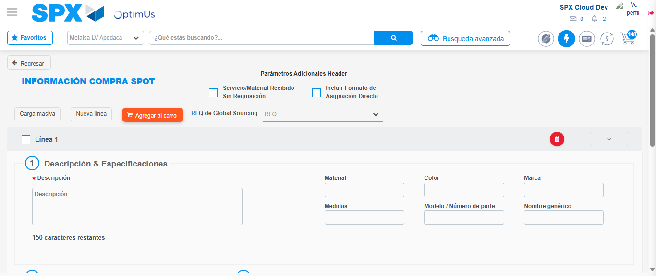Image file-name: QC_Testing-tc003_SPX_Dev5_Crear_Requisicion_Spot_Tipo_Cobro_CC_Urgent-1783356640115

Step 3 - Data Capture Spot Buy Requisition: Data captured correctly
Image file-name: QC_Testing-tc003_SPX_Dev5_Crear_Requisicion_Spot_Tipo_Cobro_CC_Urgent-1783356640415

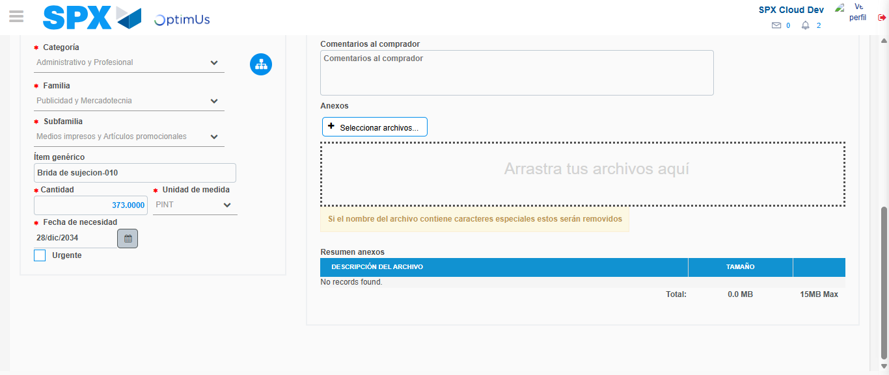Image file-name: QC_Testing-tc003_SPX_Dev5_Crear_Requisicion_Spot_Tipo_Cobro_CC_Urgent-1783356652071

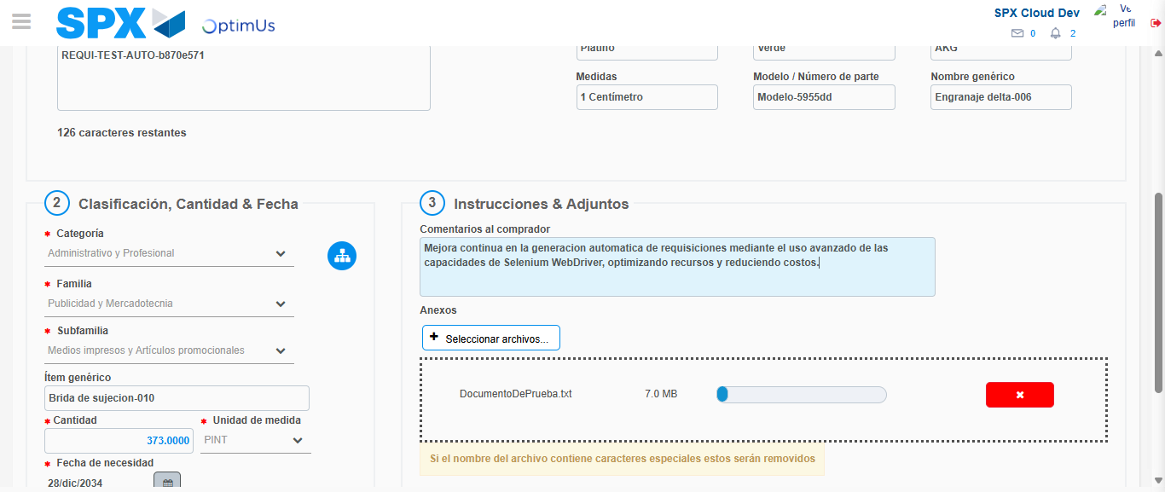Image file-name: QC_Testing-tc003_SPX_Dev5_Crear_Requisicion_Spot_Tipo_Cobro_CC_Urgent-1783356653052

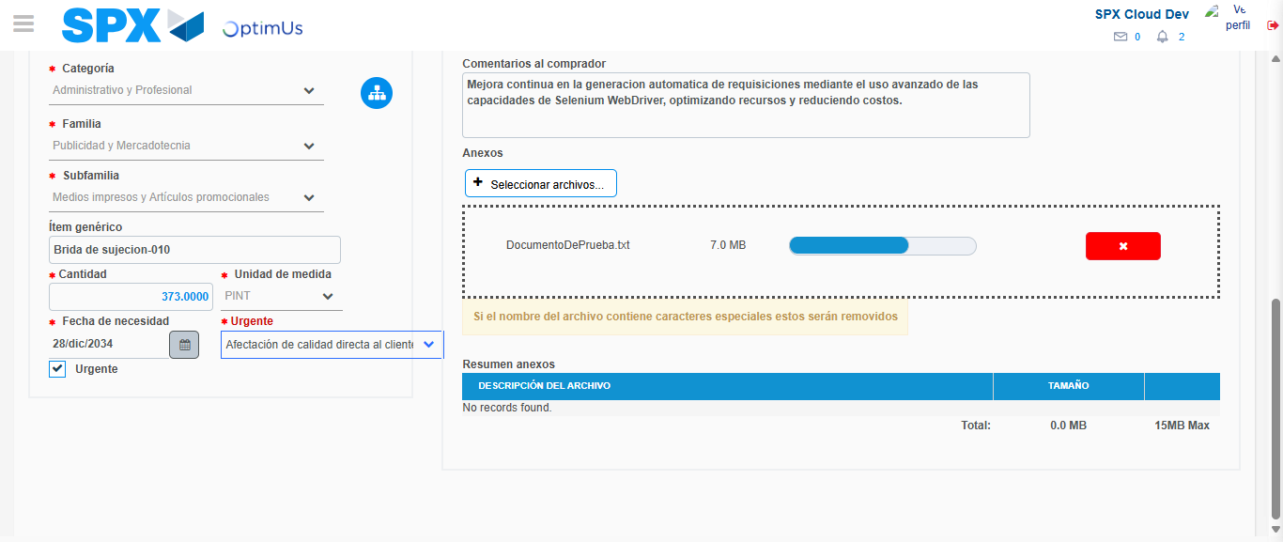Image file-name: QC_Testing-tc003_SPX_Dev5_Crear_Requisicion_Spot_Tipo_Cobro_CC_Urgent-1783356657004

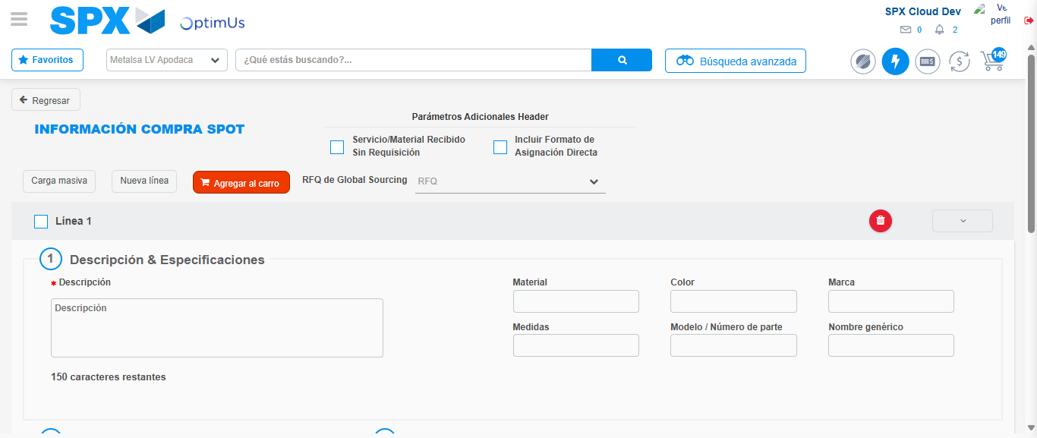Image file-name: QC_Testing-tc003_SPX_Dev5_Crear_Requisicion_Spot_Tipo_Cobro_CC_Urgent-1783356666710

Step 7 - Return to Main Page SPX : Return to Main Page SPX
Image file-name: QC_Testing-tc003_SPX_Dev5_Crear_Requisicion_Spot_Tipo_Cobro_CC_Urgent-1783356613902

Image file-name: QC_Testing-tc003_SPX_Dev5_Crear_Requisicion_Spot_Tipo_Cobro_CC_Urgent-1783356616753

Image file-name: QC_Testing-tc003_SPX_Dev5_Crear_Requisicion_Spot_Tipo_Cobro_CC_Urgent-1783356640115

Image file-name: QC_Testing-tc003_SPX_Dev5_Crear_Requisicion_Spot_Tipo_Cobro_CC_Urgent-1783356668950

Image file-name: QC_Testing-tc003_SPX_Dev5_Crear_Requisicion_Spot_Tipo_Cobro_CC_Urgent-1783356669124

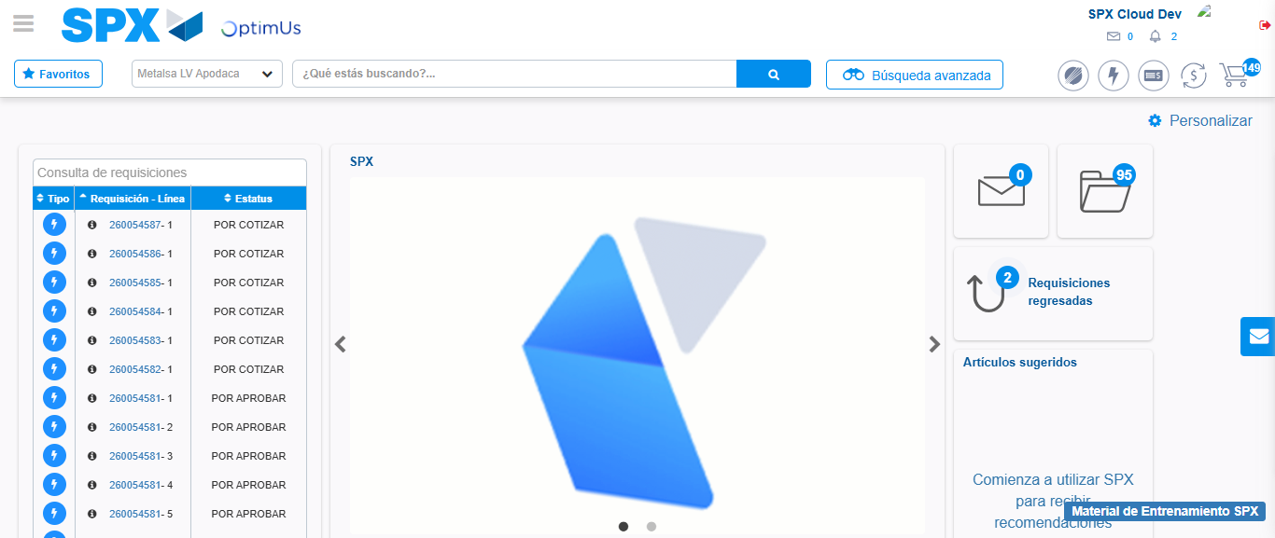Image file-name: QC_Testing-tc003_SPX_Dev5_Crear_Requisicion_Spot_Tipo_Cobro_CC_Urgent-1783356690232

Step 8 - Log Out : Log Out SPX
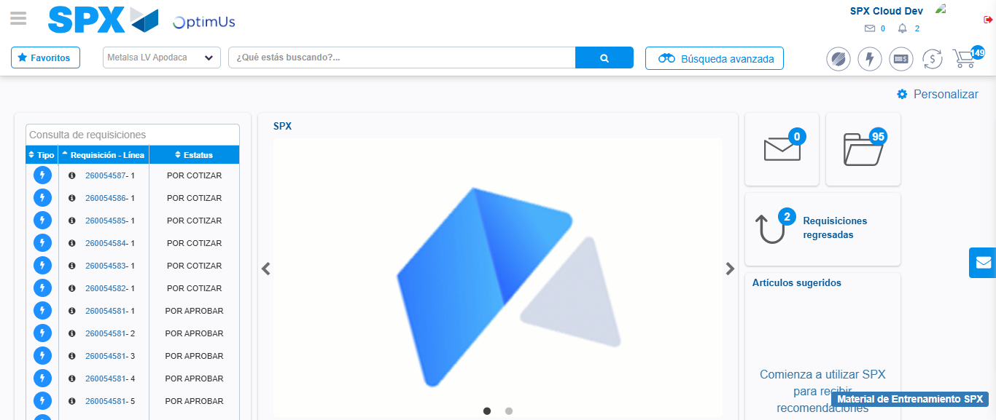Image file-name: QC_Testing-tc003_SPX_Dev5_Crear_Requisicion_Spot_Tipo_Cobro_CC_Urgent-1783356690592

